**Download RazorSQL for Mac**

1. Go to: <https://razorsql.com/index.html?adid=jq11&gclid=EAIaIQobChMIuvn1-7He3QIVgVuGCh2OWAdgEAAYAyAAEgKS8fD_BwE>
2. Downloads 🡪 Mac
3. Copy RazorSQL to Applications:

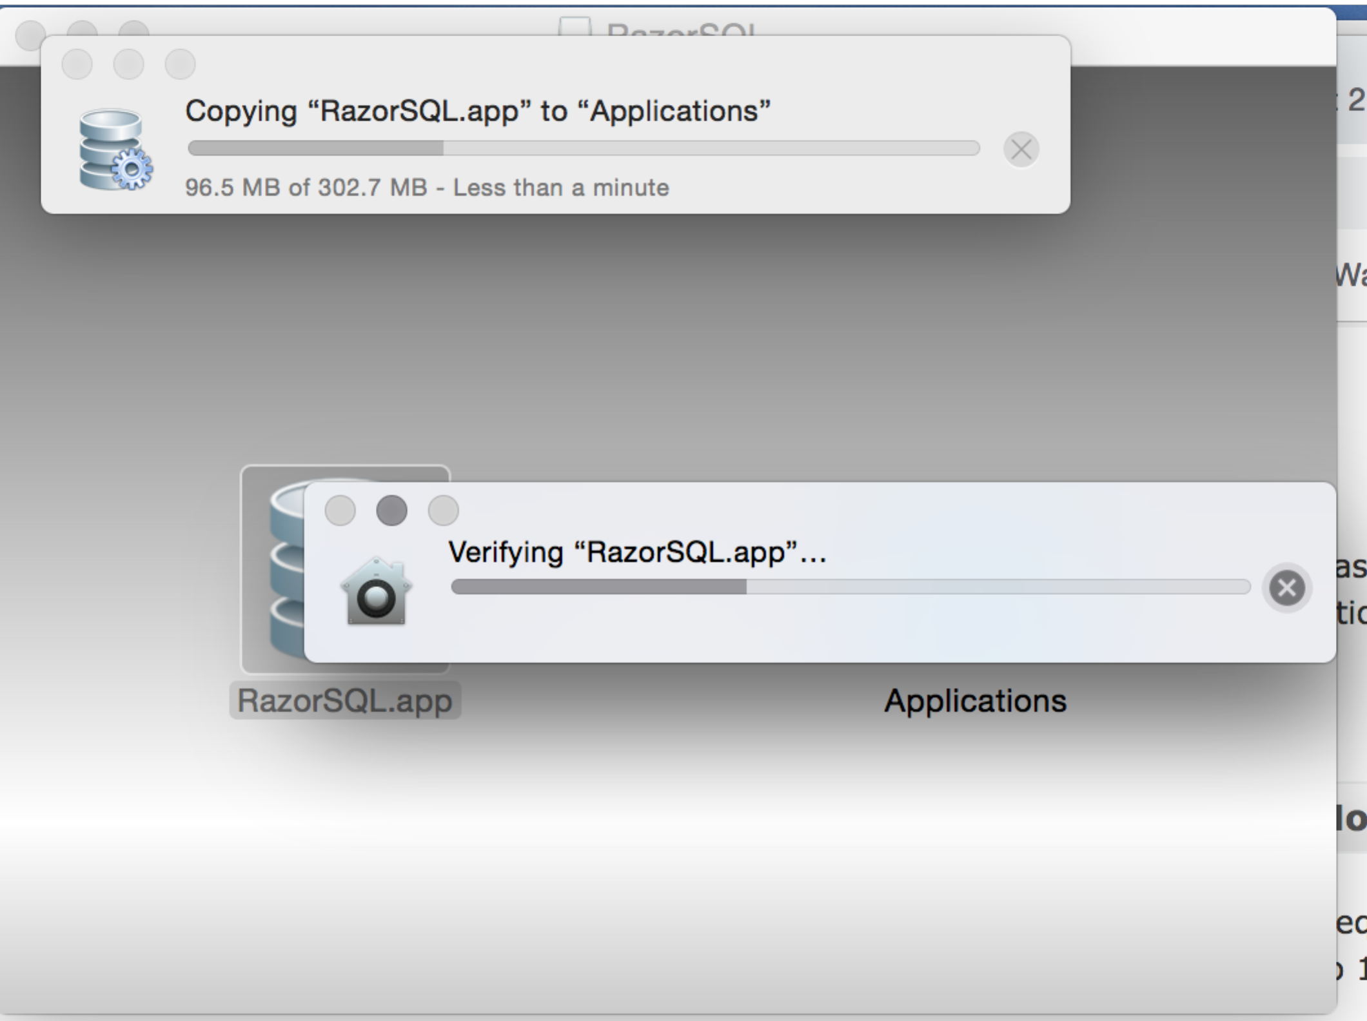

1. Chose Register Later:

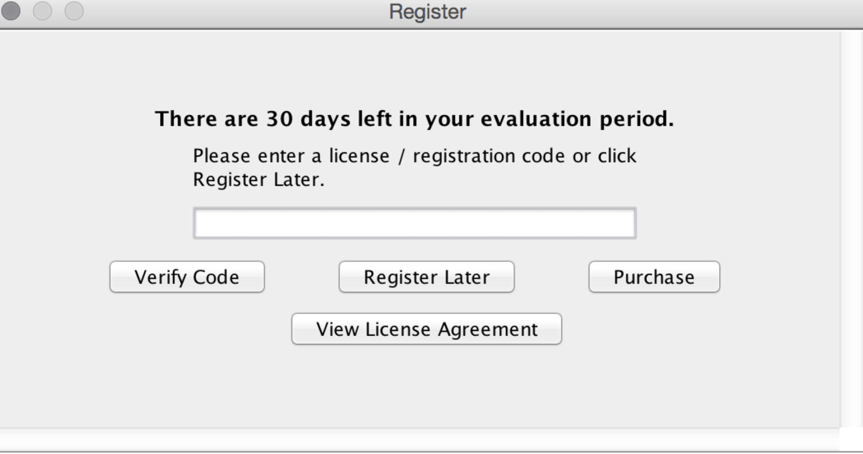

1. On the left choose **Click to Connect to Database** and chose **DynamoDB:**

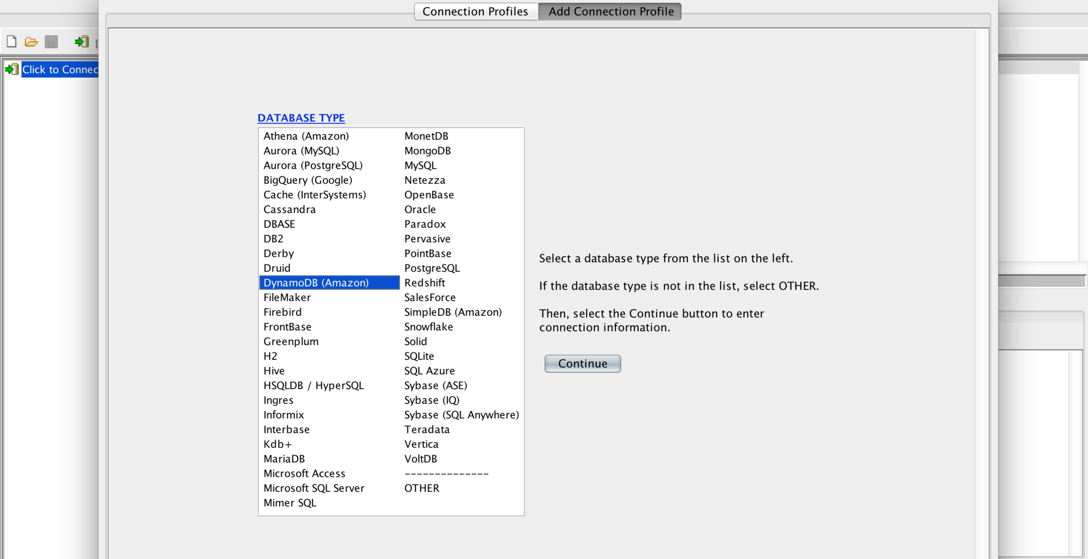

**6.** Chose **Profile Name** (whatever you want to call it), input **AWS Access Key** and **AWS Secret Key** that was emailed to you earlier, **Max Rows Per Query = 25** and leave everythig else as default. Click **Connect**.

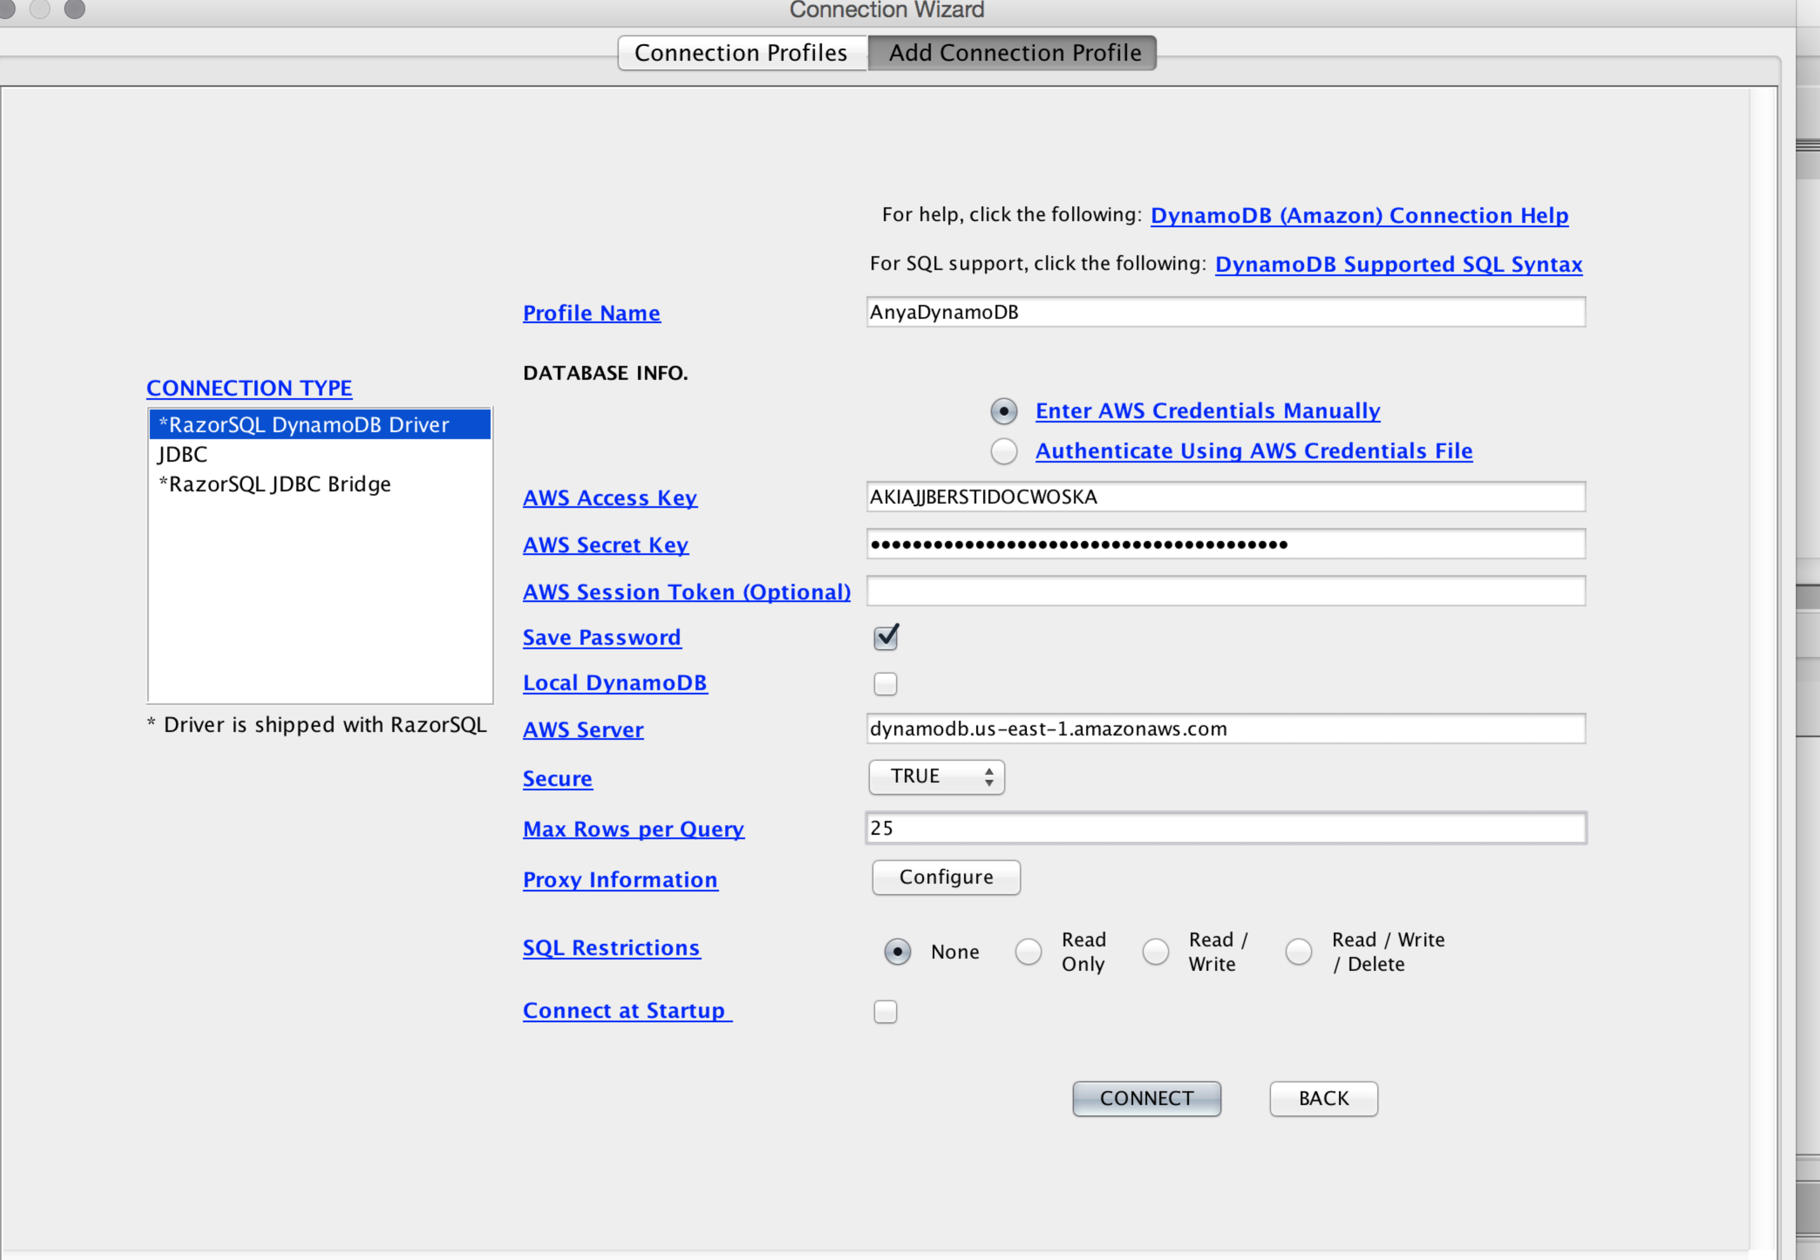

1. You should now see your tables on the left

